Question: 6:
Explore the /docs Swagger UI: try all your endpoints from the browser without writing any client code.
Question: 1: Swagger UI Screenshot:
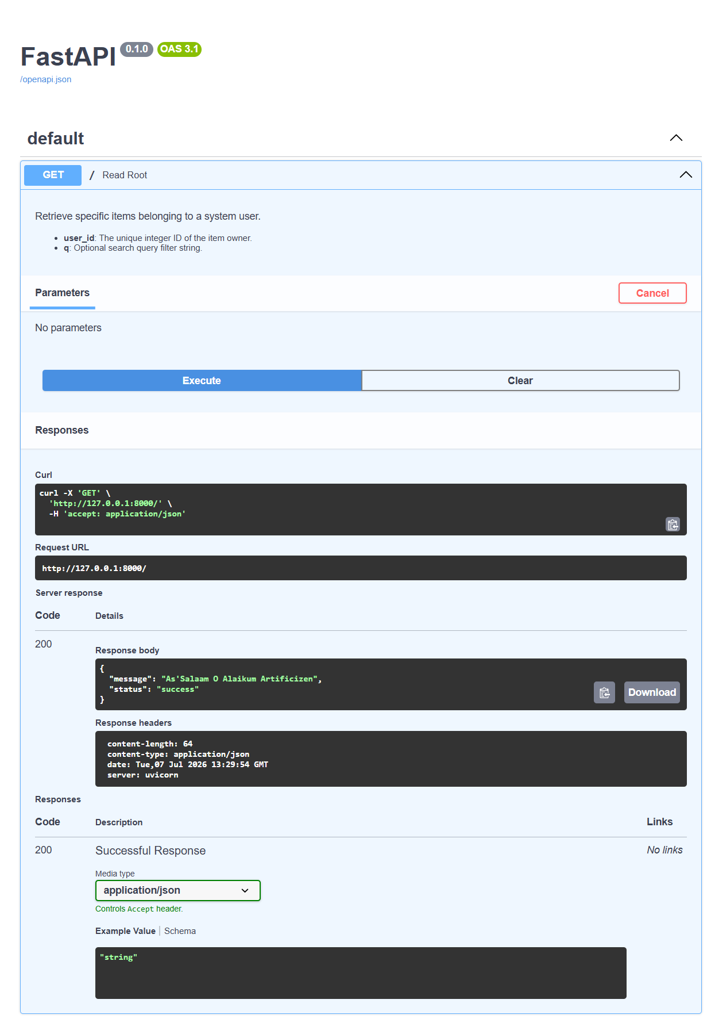

Question: 2: Swagger UI Screenshot:
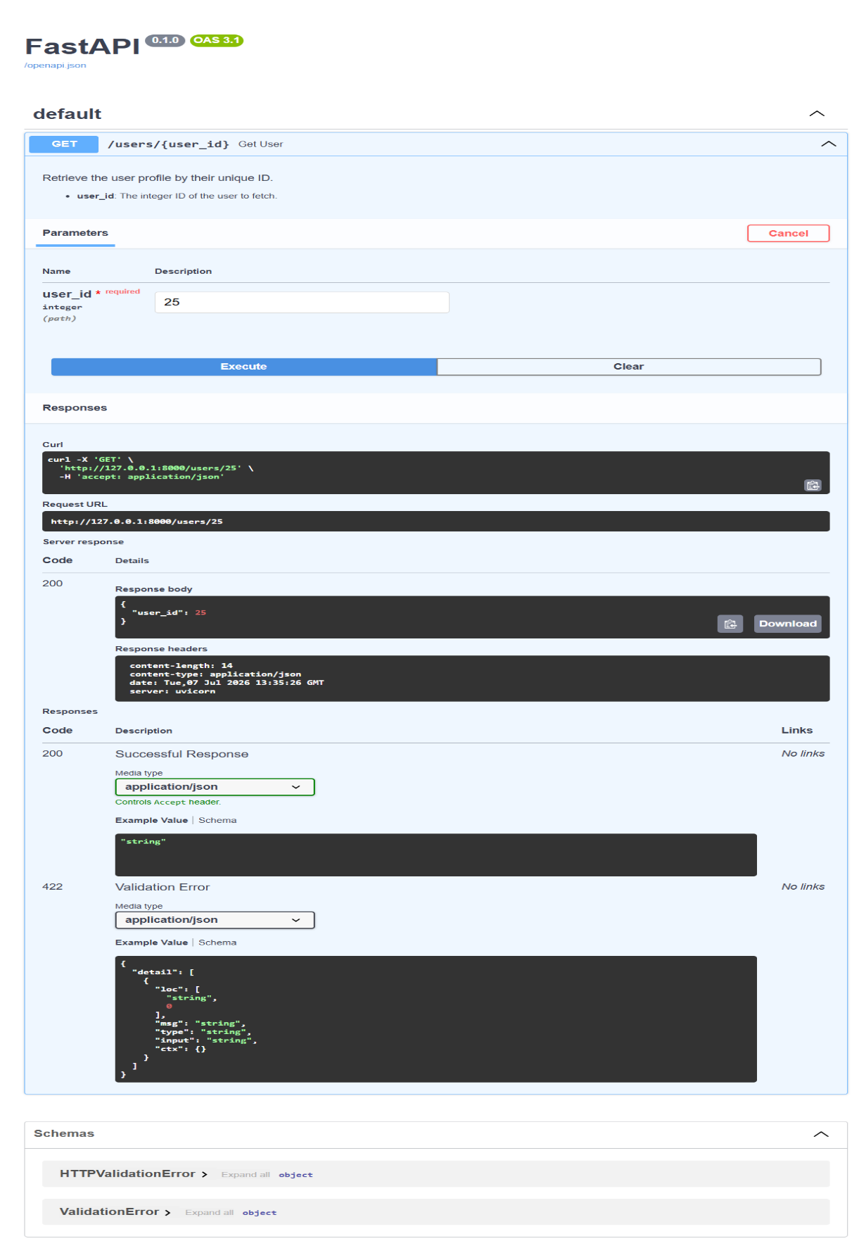

Question: 3: Swagger UI Screenshot:
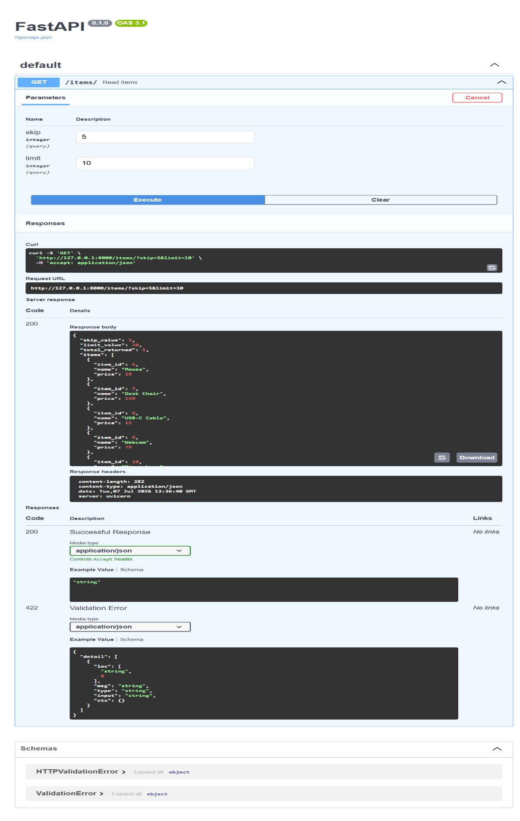

Question: 4: Swagger UI Screenshot:
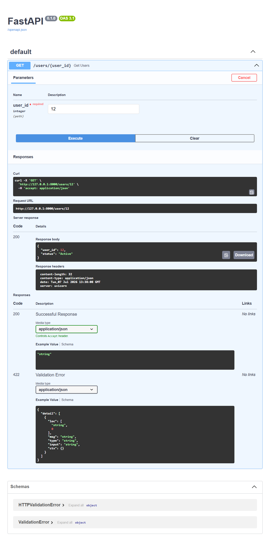
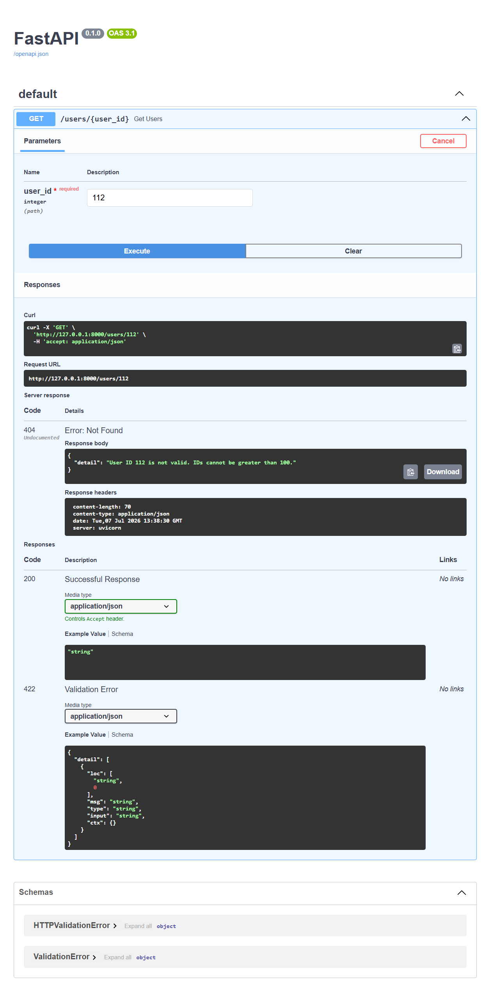
Question: 5: Swagger UI Screenshot:
